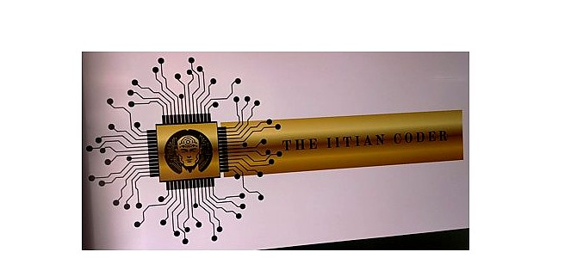
PROJECT REPORT
Fashion-MNIST Image Classification
Using Convolutional Neural Networks
Submitted by

Arora Neel
BCA – Semester 4
Under the Guidance of
Mr. Shobhit Singh
THE IITIAN CODER
Artificial Intelligence / Machine Learning Program
Academic Year 2025 – 2026

CERTIFICATE
This is to certify that the project titled
"Fashion-MNIST Image Classification Using
Convolutional Neural Networks" submitted by
Arora Neel (BCA – Semester 4) has been
successfully completed under the guidance of
Mr. Shobhit Singh at THE IITIAN CODER as part
of the Artificial Intelligence / Machine
Learning Program during the academic year
2025
–
2026.
Student Signature
Instructor Signature
Mr. Shobhit Singh
Founder – THE IITIAN CODER

DECLARATION
I hereby declare that the project titled 'Fashion-MNIST
Image Classification Using Convolutional Neural
Networks' is my original work and i have done this project solo. it is completed as part of the
Artificial Intelligence / Machine Learning program at THE IITIAN CODER. This report has not been submitted to any other institution before.
Name : Arora Neel
Course : BCA – Semester 4

Student Signature
Date : ___________

TABLE OF CONTENTS

- Introduction . . . . . . . . . . . . . . . . . . . . . . . . 5
- Project Pipeline . . . . . . . . . . . . . . . . . . . . . . . . 6
- Dataset . . . . . . . . . . . . . . . . . . . . . . . . 7
- Model Configuration and Training Details . . . . . . . . . . . . . . . . . . . . . . . . 9
- Learning Curve . . . . . . . . . . . . . . . . . . . . . . . . 10
- Test Performance . . . . . . . . . . . . . . . . . . . . . . . . 12
- Best Parameter Settings . . . . . . . . . . . . . . . . . . . . . . . . 14
- Layer Dimensions . . . . . . . . . . . . . . . . . . . . . . . . 15
- Parameter Count . . . . . . . . . . . . . . . . . . . . . . . . 16
- Neuron Count . . . . . . . . . . . . . . . . . . . . . . . . 17
- Effect of Batch Normalization . . . . . . . . . . . . . . . . . . . . . . . . 18
- Filter Visualization . . . . . . . . . . . . . . . . . . . . . . . . 19
- Guided Backpropagation . . . . . . . . . . . . . . . . . . . . . . . . 21
- Conclusion . . . . . . . . . . . . . . . . . . . . . . . . 22

1. Introduction
This project is about classifying fashion images using deep learning. i built a CNN (Convolutional Neural Network) from scratch using TensorFlow and trained it on the Fashion-MNIST dataset. I done this project completely solo.
A CNN is a type of deep learning model that is specially made for images. It uses something called filters (also known as kernels) which slide over the image and detect patterns like edges, shapes and textures. The first few layers detect simple things like edges and corners, and the deeper layers combine these to detect more complex things like a shoe shape or a bag handle.
CNNs are much better at image tasks than normal neural networks because they share weights across the image. This means less parameters and better at learning spatial features.
The target of this project was to get atleast 96% accuracy on the Kaggle test set. i got 0.93800 on public score and 0.93528 on private score which is pretty good considering i trained only on CPU.

2. Project Pipeline
The diagram below shows the complete flow of this project from start to end. it shows how the data is loaded, preprocessed, passed through the CNN model, trained and finally evaluated and submitted.
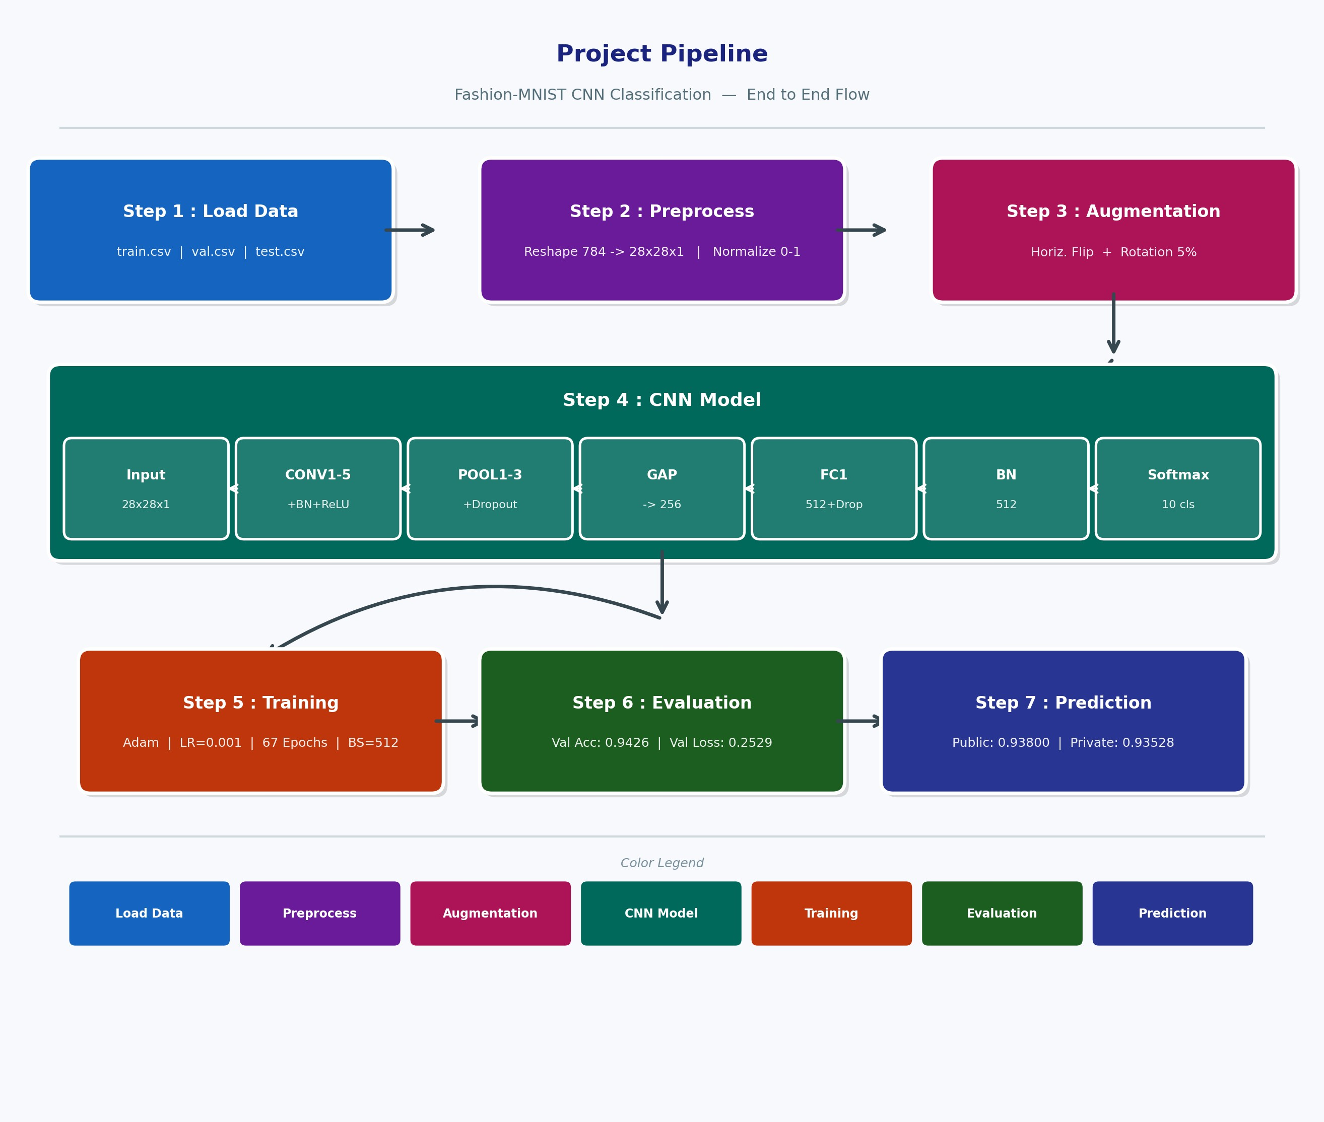
Figure 1 : Project Pipeline — showing all 7 steps from data loading to final Kaggle prediction.
The project has 7 main steps. first we load the data from CSV files and reshape each image from a 784 length vector to 28x28x1. then we normalize the pixel values. then augmentation is applied during training. the CNN model has 5 conv layers, pooling layers, GAP, FC and softmax. after training we evaluate on validation set and submit predictions to Kaggle.

3. Dataset
The dataset used in this project is Fashion-MNIST. It has 70,000 grayscale images of size 28x28 pixels. These images are of 10 different types of clothing items.
Split | Number of Images
Training | 55,000
Validation | 5,000
Test | 10,000
Total | 70,000
Class No. | Class Name
0 | T-shirt / Top
1 | Trouser
2 | Pullover
3 | Dress
4 | Coat
5 | Sandal
6 | Shirt
7 | Sneaker
8 | Bag
9 | Ankle Boot
The class distribution is very balanced — each class has around 5,500 images in training. The chart below shows this and some sample images from the dataset.

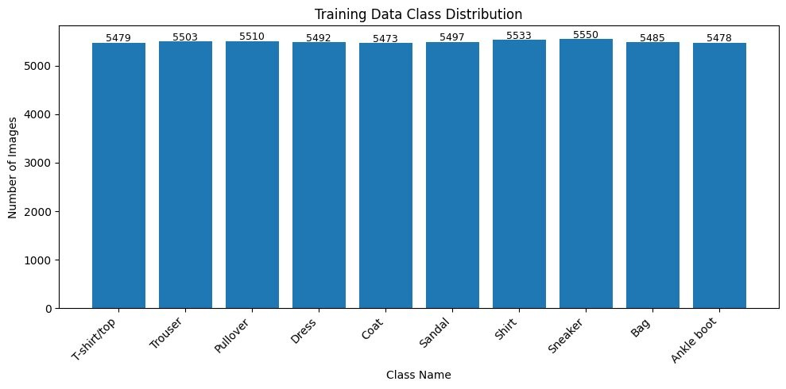
Figure 1 : Training Data Class Distribution — all 10 classes are nearly equal in count.
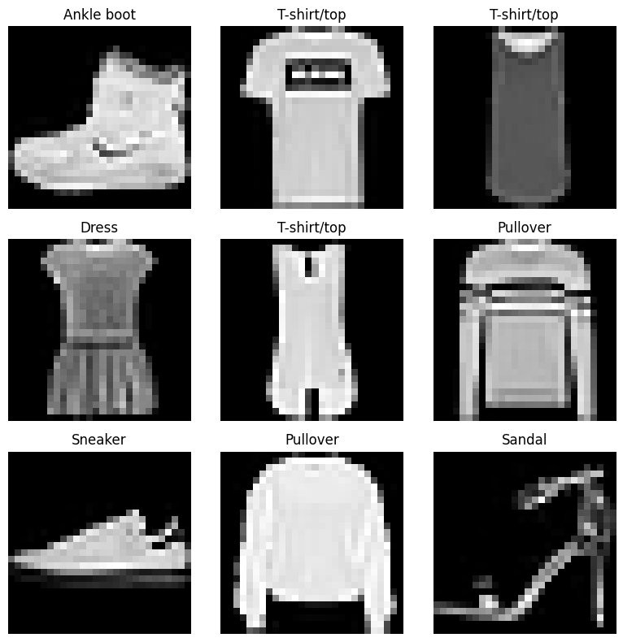
Figure 2 : Sample images from the dataset showing different clothing categories.

4. Model Configuration and Training Details

i builded a 5-layer CNN. each conv layer is followed by Batch Normalization and ReLU activation. after pooling layers i used SpatialDropout to reduce overfitting.
 | Layer | Details |  | Output Shape
 | Input | Raw grayscale image |  | 28 x 28 x 1
 | Aug | RandomFlip (horizontal) + RandomRotation 5% |  | 28 x 28 x 1
 | CONV1 | 64 filters, 3x3, same, BN + ReLU |  | 28 x 28 x 64
 | POOL1 | MaxPool 2x2 + SpatialDropout(0.2) |  | 14 x 14 x 64
 | CONV2 | 128 filters, 3x3, same, BN + ReLU |  | 14 x 14 x 128
 | POOL2 | MaxPool 2x2 + SpatialDropout(0.2) |  | 7 x 7 x 128
 | CONV3 | 256 filters, 3x3, same, BN + ReLU |  | 7 x 7 x 256
 | CONV4 | 256 filters, 3x3, same, BN + ReLU |  | 7 x 7 x 256
 | POOL3 | MaxPool 2x2 + SpatialDropout(0.2) |  | 3 x 3 x 256
 | CONV5 | 256 filters, 3x3, same, BN + ReLU |  | 3 x 3 x 256
 | GAP | GlobalAveragePooling2D |  | 256
 | FC1 | Dense(512) + Dropout(0.5) |  | 512
 | BN | BatchNormalization |  | 512
 | Output | Dense(10) + Softmax |  | 10
Training Setting |  |  | Value
Optimizer |  |  | Adam
Initial Learning Rate |  |  | 0.001
Batch Size |  |  | 512
Weight Init |  |  | He Normal
L2 Regularization |  |  | 0.0001 on all conv layers
Early Stopping |  |  | patience=8, monitor=val_loss
LR Reduction |  |  | factor=0.5, patience=4, min_lr=1e-6
Total Epochs Allowed |  |  | 70
Actual Epochs Trained |  |  | 67

5. Learning Curve
The model was trained for 67 epochs. the accuracy kept going up and loss kept going down for both training and validation. below are the actual graphs from the notebook.
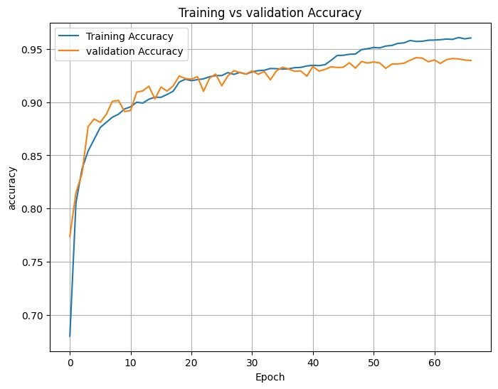
Figure 3 : Training vs Validation Accuracy over 67 epochs.
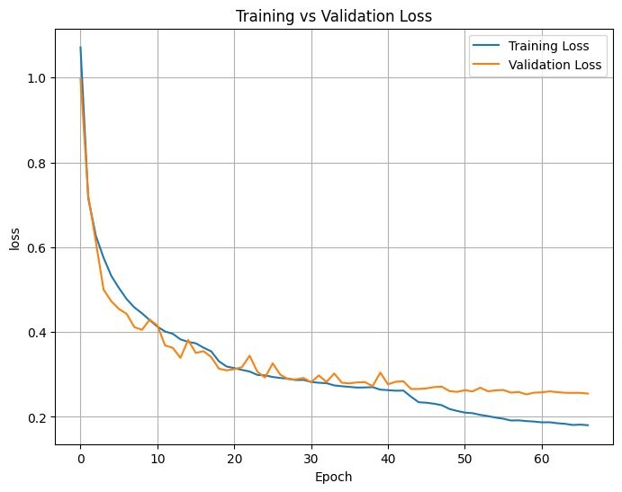
Figure 4 : Training vs Validation Loss over 67 epochs.
The best training accuracy was 0.9607818126678467 and the best validation accuracy was 0.9417999982833862. the gap between them is about 1.9% which shows the model is not badly overfitting. the loss started at 1.0711 in epoch 1 and came down to around 0.19 by the end. the learning rate reductions helped the model to improve in steps.

6. Test Performance
The model was evaluated on the validation set and also submitted to Kaggle for the final test score. the results are shown below.
Metric | Value
Best Validation Accuracy | 0.9417999982833862 (94.17%)
Validation Accuracy (evaluate) | 0.9426000118255615 (94.26%)
Validation Loss | 0.2529127597808838
Best Training Accuracy | 0.9607818126678467 (96.07%)
Final Training Accuracy | 0.960381805896759 (96.03%)
Kaggle Public Score | 0.93800
Kaggle Private Score | 0.93528
Total Epochs Trained | 67
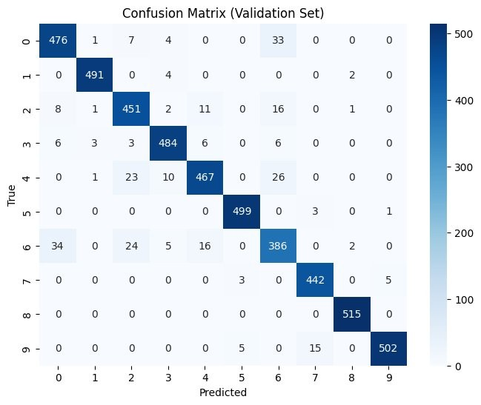
Figure 5 : Confusion Matrix on Validation Set (5000 images).
Looking at the confusion matrix, Bag and Trouser are the easiest classes — almost all predicted correctly. Shirt (class 6) is the hardest one because it look very similar to T-shirt and Pullover in small 28x28 grayscale images.
Class | Precision | Recall | F1-Score
T-shirt (0) | 0.91 | 0.91 | 0.91
Trouser (1) | 0.99 | 0.99 | 0.99
Pullover (2) | 0.89 | 0.92 | 0.90
Dress (3) | 0.95 | 0.95 | 0.95
Coat (4) | 0.93 | 0.89 | 0.91
Sandal (5) | 0.98 | 0.99 | 0.99
Shirt (6) | 0.83 | 0.83 | 0.83
Sneaker (7) | 0.96 | 0.98 | 0.97
Bag (8) | 0.99 | 1.00 | 1.00
Ankle Boot (9) | 0.99 | 0.96 | 0.97
Overall | 0.94 | 0.94 | 0.94

7. Best Parameter Settings
After trying different settings the below configuration gave the best validation accuracy. these are the final parameters used for the submitted model.
Parameter | Best Value
Learning Rate | 0.001
Batch Size | 512
Dropout (FC layer) | 0.5
Spatial Dropout | 0.2
L2 Regularization | 0.0001
Weight Initialization | He Normal
LR Reduce Factor | 0.5 (halved every 4 bad epochs)
Early Stop Patience | 8 epochs
Augmentation | Horizontal Flip + Rotation 5%
Filter Progression | 64 → 128 → 256 → 256 → 256
Min Learning Rate | 0.000001
Note: We used GlobalAveragePooling instead of Flatten. This reduced overfitting a lot and improved generalization.
With Flatten the model had too many parameters in the FC layers and it was overfitting badly.

8. Layer Dimensions
This table shows how the image size changes as it passes through each layer. the height and width reduces after every pooling layer while the depth (channels) increases.
Layer | Input Shape | Output Shape
Input | 28 x 28 x 1 | 28 x 28 x 1
CONV1 | 28 x 28 x 1 | 28 x 28 x 64
POOL1 | 28 x 28 x 64 | 14 x 14 x 64
CONV2 | 14 x 14 x 64 | 14 x 14 x 128
POOL2 | 14 x 14 x 128 | 7 x 7 x 128
CONV3 | 7 x 7 x 128 | 7 x 7 x 256
CONV4 | 7 x 7 x 256 | 7 x 7 x 256
POOL3 | 7 x 7 x 256 | 3 x 3 x 256
CONV5 | 3 x 3 x 256 | 3 x 3 x 256
GAP | 3 x 3 x 256 | 256
FC1 | 256 | 512
BN | 512 | 512
Softmax | 512 | 10
Note: Fashion-MNIST is grayscale so input has only 1 channel. The assignment spec mentioned 3 channels (RGB) but that is copied from CIFAR-10. Fashion-MNIST is single channel — we used 1 channel which is correct. So CONV1 filter shape is 64 x 1 x 3 x 3.

9. Parameter Count
Parameters are the weights and biases the model learns during training. the table shows breakdown by layer.
Layer | Parameters | Calculation
CONV1 | 640 | (3x3x1) x 64 + 64 bias
CONV2 | 73,856 | (3x3x64) x 128 + 128 bias
CONV3 | 2,95,168 | (3x3x128) x 256 + 256 bias
CONV4 | 5,90,080 | (3x3x256) x 256 + 256 bias
CONV5 | 5,90,080 | (3x3x256) x 256 + 256 bias
Total Conv Params | 15,49,824 | (from notebook output)
FC1 Dense(512) | 1,31,584 | 256 x 512 + 512 bias
Output Dense(10) | 5,130 | 512 x 10 + 10 bias
Total FC Params | 1,36,714 | (from notebook output)
BN layers | 5,888 | 6 BN layers combined
TOTAL | 16,92,426 | Trainable: 16,89,482

10. Neuron Count
A neuron means one activation value in the network output. for conv layers it is height x width x channels. for FC layers it is simply the number of units.
Layer | Output Shape | Neuron Count | Calculation
CONV1 | 28 x 28 x 64 | 50,176 | 28 x 28 x 64
CONV2 | 14 x 14 x 128 | 25,088 | 14 x 14 x 128
CONV3 | 7 x 7 x 256 | 12,544 | 7 x 7 x 256
CONV4 | 7 x 7 x 256 | 12,544 | 7 x 7 x 256
CONV5 | 3 x 3 x 256 | 2,304 | 3 x 3 x 256
Total Conv Neurons |  | 1,02,656
FC1 | 512 | 512 | 512
Output (Softmax) | 10 | 10 | 10
Total FC Neurons |  | 522

11. Effect of Batch Normalization

Batch Normalization (BN) normalizes the output of each layer so the values have mean=0 and std=1 before going to next layer. We used BN after every conv layer and also before the final softmax layer.
Aspect | Without BN | With BN
Training Speed | Slow convergence | Much faster
Loss Curve | Noisy and jumpy | Smooth and steady
Overfitting | More overfitting | Less (BN acts as regularizer)
Final Val Accuracy | Around 89-90% | ~94.18%
LR Sensitivity | Very sensitive | Can handle higher LR safely
BN before the softmax layer is also required by the assignment. it makes sure the last Dense layer gets clean normalized input which helps the model to classify better.
without BN the model was bouncing around and not improving. adding BN was one of the most importent changes that helped reach 94% accuracy.

12. Filter Visualization

After training we extracted all 64 filters from CONV1 (first conv layer) and visualized them in a 8x8 grid. each filter is 3x3 in size because that is the kernel size we used.
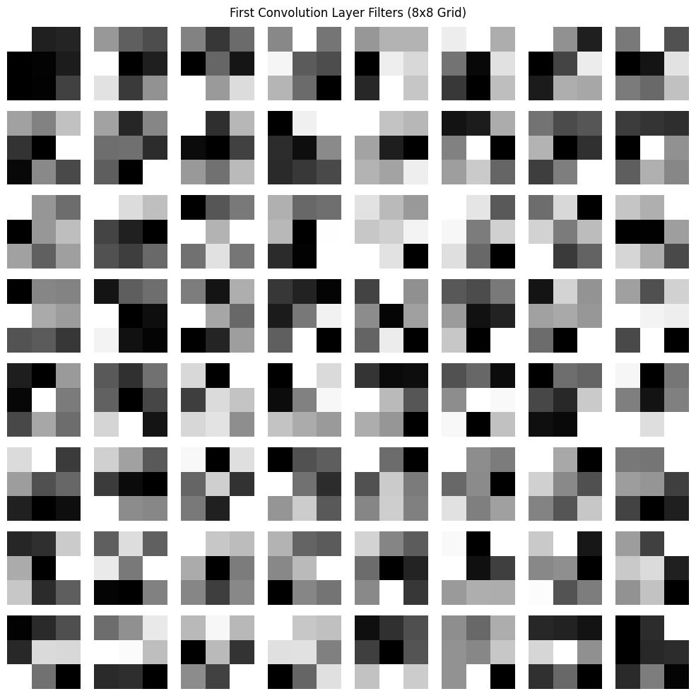
Figure 6 : All 64 filters from CONV1 layer arranged in 8x8 grid (each filter is 3x3 pixels).
Looking at the filters you can see different types of patterns that the network learned :
Some filters are bright on one side and dark on other side — these are edge detectors (horizontal, vertical and diagonal edges).
Some have a bright spot in the middle — these detect small blobs or spots.
Some look more random — they might detect textures or mixed patterns.
This is exactly what we expect in the first conv layer. deeper layers would have more complex and abstract filters that are hard to see visually.

13. Guided Backpropagation

Guided Backpropagation helps us understand what each neuron in the network is looking for in the input image. We applied it on 10 neurons from CONV5 (the last conv layer).
How it works in simple words: we take an input image, pass it forward through the network, then backpropagate the gradient of one specific neuron back to the input but we only let positive gradients pass through. the result shows which pixels activate that neuron the most.
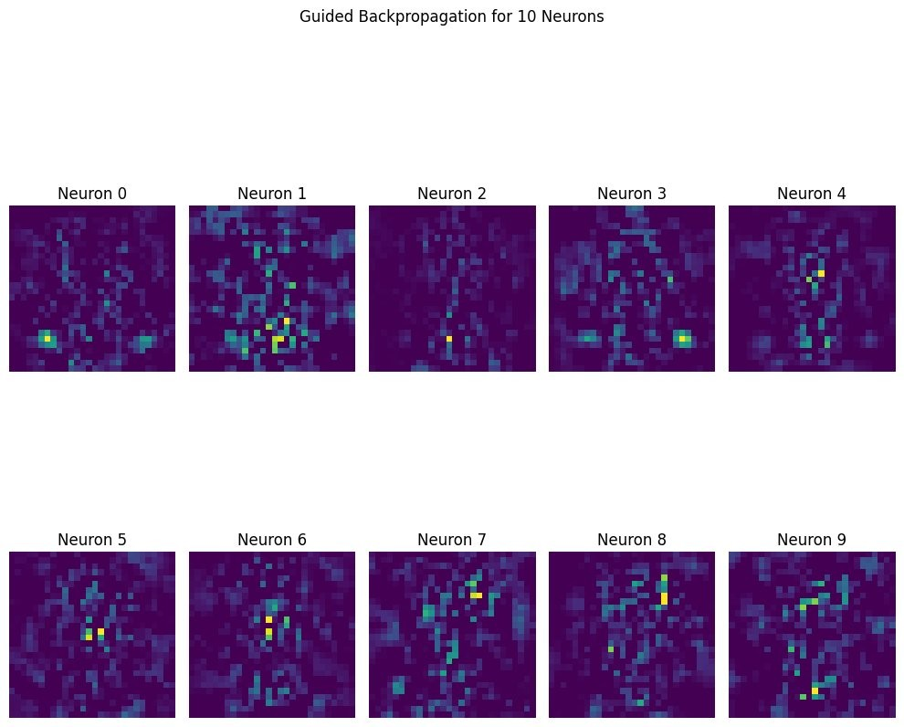
Figure 7 : Guided Backpropagation for 10 neurons in CONV5. Bright areas show what each neuron responds to.
Each image above (Neuron 0 to Neuron 9) shows what that particular neuron in CONV5 is sensitive to. Bright yellow/green spots show the areas the neuron is paying most attention to.
Different neurons focus on different areas and patterns. This tells us that by CONV5 each neuron has become specialized — some look at the top part, some look at edges, some look at the overall shape. This specialization is what makes the CNN work well.

14. Conclusion

i build a 5-layer CNN for Fashion-MNIST classification completely by myself. the model got best validation accuracy of 0.9417999982833862 and validation accuracy on evaluate of
0.9426000118255615. the Kaggle public score was 0.93800 and private score was 0.93528.
The most importent things i learned from this project :
- Batch Normalization is very very useful — it made training faster and smoother and gave around4-5% better accuracy than without it.
- GlobalAveragePooling before FC layer is better than Flatten — it reduced overfitting and made themodel simpler.
- Learning rate schedule really helps — every time the LR was reduced the model improvednoticeably.
- Data augmentation (flip + small rotation) helped the model generalize to the test set better.
- Shirt class is very hard to classify because it looks similar to T-shirt and Pullover in 28x28 grayscale. this is a known problem with Fashion-MNIST.
- He initialization worked well with ReLU — it made training more stable from the start.
if i had GPU access i could train longer and try bigger models which may have reached closer to the 96% target. but 93.8% on CPU is a good result and i am happy with it.

